Project Management Plan

Petoskey School Web presence refactoring

Petoskey Schools

1500 Hill Street

Petoskey, Michigan, 49970

1/18/15

INTRODUCTION

We as a team are going to re-factor Petoskey School’s web presence and redevelop the entire web infrastructure of the main district web pages as well as teacher sites. Overall, this will make sure that everything on the webpages will function properly and be attractive on the users end. This overall increase the performance from going from one webpage to another as well.

PROJECT MANAGEMENT APPROACH

Allotted a three-week window to get this finished, we will need to stay focused on getting everything done not just on time, but before it’s time. To do this we are going to use Time Management and split everyone in to groups to work on what’s at hand accordingly. We will need 2 working on the back-end and 2 working on the front end of the website, while we have our project planner and our testers; which, will also be programming on both ends of the webpages.

PROJECT SCOPE

We are given three-months to have this project fully developed, tested, and finished for use.

|  |  |  |  |  |
| --- | --- | --- | --- | --- |
| Research |  |  |  |  |
| Initial Report |  |  |  |  |
| Coding & GUI |  |  |  |  |
| Final Report |  |  |  |  |
|  | Jan | Feb | Mar | Apr |

3 Month Window (Mid Jan – Mid Apr)

In the first month we should do most of the research needed, but also already be working on the project by at least week 3 of that month. This will give us some heads up for the next month of coding, initial report and the Graphical User Interface.

MILESTONE LIST

Throughout the whole project stay in contact with client and get as much information on how they would like the webpages to function/look.

|  |  |  |
| --- | --- | --- |
| Milestone | Description | Date |
| Project prep – discussion, and assigning each accordingly to the project’s needs. | Discuss and talk about how we are going to go about developing the website, and give each team-member an assignment/list of what needs done. | Jan 26th, 2015 |
| Complete information gathering and figure out overall costs and needs. | Decide the overall cost of the project and make sure the price is right for both the client and our business. | February 9th, 2015 |
| Start developing on the website (Front and Back end). Included GUI. | Have all the information needed for webpages gathered as well as understanding on how to cooperatively code front and back-end of the webpages. | February 16th -20th, 2015 |
| Test the webpages | Make sure everything functions properly, and review the website as a whole. Make changes as needed. | March 2nd, 2015 |
| Complete the project | Go over project one last time, changes should only be made if mandatory. Everything should be finished at this point. | March 9th, 2015 |
| Client overview and presentation | Present the finished project to the client and get their feedback. | March 16th, 2015 |
| Overview changes | Make any changes that the client was wanting to the website (reasonably) | March 23rd, 2015 |
| Represent the website | Represent the website to client. | March 30th, 2015 |
| Finish and upload the project | Take the old webpages of the website and create and store it as a backup (on their local server). Make new site live. | March 30th – April 6th, 2015 |

CHANGE MANAGEMENT

Throughout the whole entire lifecycle of the project we will be staying in contact with the client and making rational changes to the way we will be creating and structuring the website. This will include both the GUI and the backend of the website. The way it functions as well as looks cooperatively. We will have one of our team-members stay in contact and be the one who talks with the client so the client doesn’t have to remember all of our names and to have all the information coherent with one team-member (which will write down all the ideas/changes)

If there is changes that need to be taken place we will discuss them with the team as a whole and see if it would be beneficial to both parties. We would evaluate the change ideas and try to meet the expectations of the client, but try not to travel too far outside the scope of the project.

Process:

Identify need for change

Log change in the change request (from client)

Conduct evaluation of the change

Submit change request to CCB (Change Control Board) (Project Manager)

CCB decision

Implement change (Project Manager)

(Project Sponsor will chair the CCB and any changes to project scope, cost, or schedule must meet his approval)

COMMUNICATION MANAGEMENT PLAN

We will communicate via email and by phone when needed. We will contact the client on a weekly and if needed daily basis.

We will provide all the information that is relevant to client every week. We will have one team-member always staying in contact with the client and exchanging all the information via email and phone. Also, if it is needed we will create a Communications Matrix to use as a guide on the best times to communicate with the client and how to communicate.

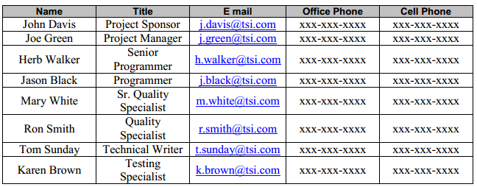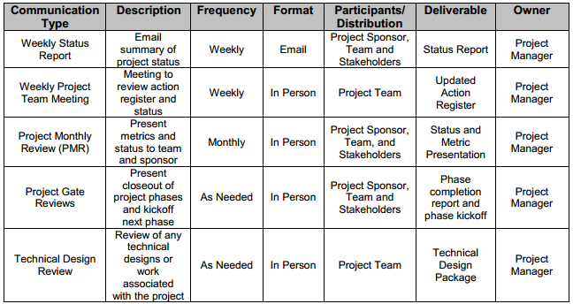

Project team directory for all communication that will be provided to the client:

Communications Conduct:

Meetings:

The Project Manager will distribute a meeting agenda at least 2 days prior to any scheduled meeting and all participants are expected to review the agenda prior to the meeting. During all project meetings the timekeeper will ensure that the group adheres to the times stated in the agenda and the recorder will take all notes for distribution to the team upon completion of the meeting. It is imperative that all participants arrive to each meeting on time and all cell phones and blackberries should be turned off or set to vibrate mode to minimize distractions. Meeting minutes will be distributed no later than 24 hours after each meeting is completed.

Email: All email pertaining to the Project should be professional, free of errors, and provide brief communication. Email should be distributed to the correct project participants in accordance with the communication matrix above based on its content. All attachments should be in one of the organization’s standard software suite programs and adhere to established company formats. If the email is to bring an issue forward then it should discuss what the issue is, provide a brief background on the issue, and provide a recommendation to correct the issue. The Project Manager should be included on any email pertaining to the Project.

Informal Communications: While informal communication is a part of every project and is necessary for successful project completion, any issues, concerns, or updates that arise from informal discussion between team members must be communicated to the Project Manager so the appropriate action may be taken.

COST MANAGEMENT PLAN

We will have one cost manager on our team that is constantly reviewing the overall costs of the project. Although we will be always monitoring our costs, we will specifically designate one team member to monitor it entirely.

PROCUREMENT MANAGEMENT PLAN

The Project Manager will provide oversight and management for all procurement activities under this project. The Project Manager is authorized to approve all procurement actions up to $50,000. Any procurement actions exceeding this amount must be approved by the Project Sponsor.

While this project requires minimal or no procurement, in the event procurement is required, the Project Manager will work with the project team to identify all items or services to be procured for the successful completion of the project. The Project Manager will then ensure these procurements are reviewed by the Program Management Office (PMO) and presented to the contracts and purchasing groups. The contracts and purchasing groups will review the procurement actions, determine whether it is advantageous to make or buy the items or resource required services internally, and begin the vendor selection, purchasing and the contracting process.

In the event a procurement becomes necessary, the Project Manager will be responsible for management any selected vendor or external resource. The Project Manager will also measure performance as it relates to the vendor providing necessary goods and/or services and communicate this to the purchasing and contracts groups.

PROJECT SCOPE MANAGEMENT PLAN

Failure to clearly establish and communicate project scope can result in delays, unnecessary work, and failure to achieve deliverables, cost overruns, or other unintended consequences; which, is why we are going to approach to managing the projects’ scope and clearly define it in documented detail. Scope will be defined in a Scope Statement and will be measured and verified with Work Performance Measurements in the supported Gantt chart.

Once a preliminary schedule has been developed, it will be reviewed by the project team and any resources tentatively assigned to project tasks. The project team and resources must agree to the proposed work package assignments, durations, and schedule. Once this is achieved the project sponsor will review and approve the schedule and it will then be base lined.

QUALITY MANAGEMENT PLAN

Our team as a whole will always be checking on the quality of the project and in different aspects. The Project sponsor will review all project tasks and deliverables to ensure compliance with the established and approved quality standards. Additionally, the Project Sponsor will sign off on the final acceptance of the project deliverable.

The Project Manager is responsible for quality management throughout the duration of the project. The Project Manager is responsible for implementing the Quality Management Plan and ensuring all tasks, processes, and documentation are compliant with the plan. The Project Manager will work with the project’s quality specialists to establish acceptable quality standards. The Project Manager is also responsible for communicating and tracking all quality standards to the project team and stakeholders.

The Quality Specialists are responsible for working with the Project Manager to develop and implement the Quality Management Plan. Quality Specialists will recommend tools and methodologies for tracking quality and standards to establish acceptable quality levels. The Quality Specialists will create and maintain Quality Control and Assurance Logs throughout the project.

The remaining member of the project team, as well as the stakeholders will be responsible for assisting the Project Manager and Quality Specialists in the establishment of acceptable quality standards. They will also work to ensure that all quality standards are met and communicate any concerns regarding quality to the Project Manager.

Quality control for the Project will utilize tools and methodologies for ensuring that all project deliverables comply with approved quality standards. To meet deliverable requirements and expectations, we must implement a formal process in which quality standards are measured and accepted. The Project Manager will ensure all quality standards and quality control activities are met throughout the project. The Quality Specialists will assist the Project Manager in verifying that all quality standards are met for each deliverable. If any changes are proposed and approved by the Project Sponsor and CCB, the Project Manager is responsible for communicating the changes to the project team and updating all project plans and documentation.

Quality assurance for the Project will ensure that all processes used in the completion of the project meet acceptable quality standards. These process standards are in place to maximize project efficiency and minimize waste. For each process used throughout the project, the Project Manager will track and measure quality against the approved standards with the assistance of the Quality Specialists and ensure all quality standards are met. If any changes are proposed and approved by the Project Sponsor and CCB, the Project Manager is responsible for communicating the changes to the project team and updating all project plans and documentation.

RISK MANAGEMENT PLAN

The approach for managing the risks for the Project will be a process by which the project team identifies and ranks all the various risks. Every effort will be made to identify risks ahead of time in order to implement a mitigation strategy from the beginning of the Project. Risk managers will provide status updates on their assigned risks in bi-weekly project team meetings, but only when the meetings include their risk’s planned timeframe.

Upon the completion of the project, during the closing process, the project manager will analyze each of the risks as well as the risks management process. The project manager will identify any improvements that can be made to the risk management process for the future projects; also, these improvements will be captured as part of the lessons learned and incorporated into the knowledge base.

STAFFING MANAGEMENT PLAN

Senior Programmer (1 position) – responsible for oversight of all coding and programming tasks for the Project as well as ensuring functionality is compliant with quality standards. Responsible for working with the Project Manager to create work packages, manage risk, manage schedule, identify requirements, and create reports. The Senior Programmer will be managed by the Project Manager who will provide performance feedback to the functional manager.

Programmer (1 position) – responsible for coding and programming for the Project. All coding and programming tasks will be reviewed by the Senior Programmer prior to implementation. Responsibilities also include assisting with risk identification, determining impacts of change requests, and status reporting. The Programmer will be managed by the Project Manager and feedback will be provided to the functional manager for performance evaluations by the Project Manager and Senior Programmer.

Senior Quality Specialist (1 position) – responsible for assisting the Project Manager in creating quality control and assurance standards. The Senior Quality Specialist is also responsible for maintaining quality control and assurance logs throughout the project. The Senior Quality Specialist will be managed by the Project Manager who will also provide feedback to the functional manager for performance evaluations.

Quality Specialist (1 position) – responsible for assisting the Project Manager and Senior Quality Specialist in creating and tracking quality control and assurance standards. The Quality Specialist will have primary responsibility for compiling quality reporting and metrics for the Project Manager to communicate. The Quality Specialist will be managed by the Project Manager who will provide feedback, along with the Senior Quality Specialist to the functional manager for performance evaluations.

Technical Writer (1 position) – responsible for compiling all project documentation and reporting into organizational formats. Responsible for assisting the Project Manager in Configuration Management and revision control for all project documentation. Responsible for scribing duties during all project meetings and maintaining all project communication distribution lists. The Technical Writer will be managed by the Project Manager who will also provide feedback to the functional manager for performance evaluations.

Testing Specialist (1 position) – responsible for helping establish testing specifications for the Project with the assistance of the Project Manager and Programmers. Responsible for ensuring all testing is complete and documented in accordance with TSI standards. Responsible for ensuring all testing resources are coordinated. The Testing Specialist will be managed by the Project Manager who will also provide feedback to the functional manager for performance evaluations.

The Project Manager will negotiate with all necessary TSI functional managers in order to identify and assign resources for the Project. All resources must be approved by the appropriate functional manager before the resource may begin any project work. The project team will not be co-located for this project and all resources will remain in their current workspace.

RESOURCE CALENDAR

The Project will require all project team members for the entire duration of the project although levels of effort will vary as the project progresses. The Project is scheduled to last one year with standard 40 hour work weeks. If a project team member is not required for a full 40 hour work week at any point during the project, their efforts outside of the Project will be at the discretion of their Functional Manager.

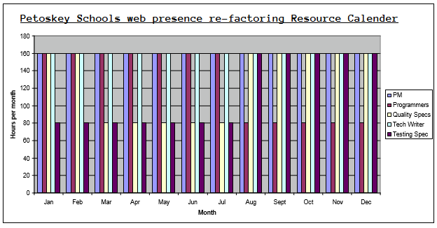

COST BASELINE

The cost baseline for the Project includes all budgeted costs for the successful completion of the project.

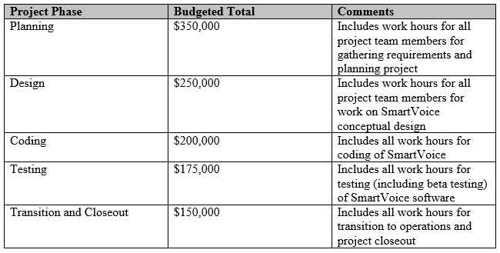

QUALITY BASELINE

The Project must meet the quality standards established in the quality baseline. The quality baseline is the baseline which provides the acceptable quality levels of the Project. The software must meet or exceed the quality baseline values in order to achieve success.

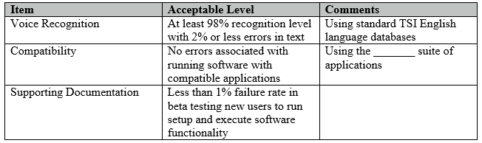

SPONSOR ACCEPTANCE

Approved by the Project Sponsor:

__________________________________________ Date: ___________________

<Project Sponsor>

<Project Sponsor Title>

Sources used: <http://www.projectmanagementdocs.com/template/Project-Management-Plan.pdf>

<https://en.wikipedia.org/wiki/Outline_of_project_management>

<https://en.wikipedia.org/wiki/Business_case>

<https://en.wikipedia.org/wiki/Project_management>

Credits: www.ProjectManagementDocs.com